ME 270

**Mini Project 5**

Machining

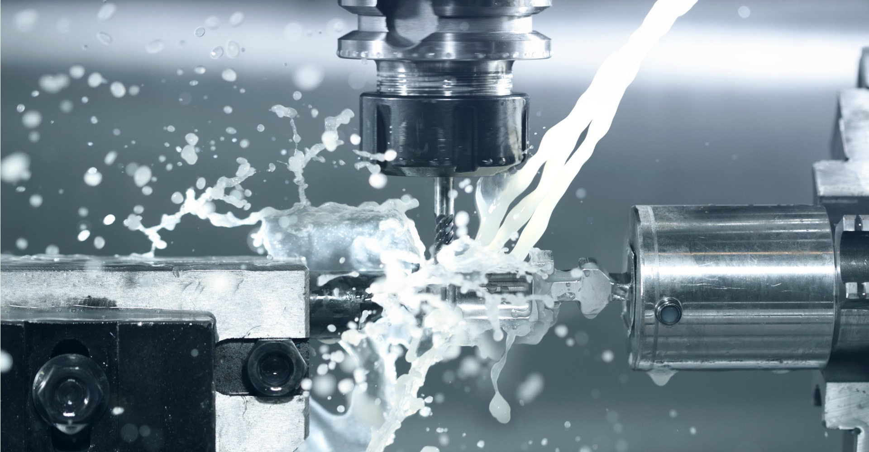

Group: ABG_2

Group Members: Alice Lin, Brian Lee, Ryan Phoon

Due Date: 10/29/2020

1. **ANALYSIS**
   1. Do research on the Internet and find examples of integral machining (e.g. where machining is of primary importance for the functioning of the product), and machining as a secondary process (e.g. where machining is used only to provide a better surface finish, for instance). Show pictures of these and provide brief explanatory text. (10)

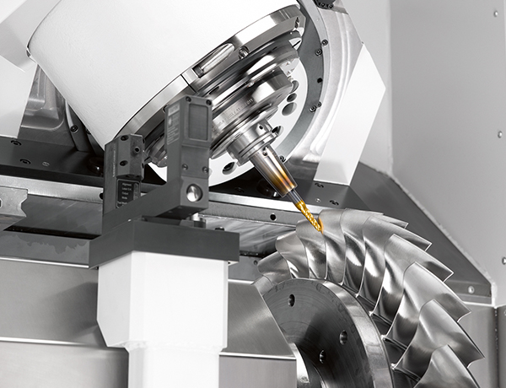

**Figure 1. Machining of a turbine blade with a 5-axis CNC machine.**

CNC machining is used very commonly in the aerospace industry to manufacture parts. Aerospace machining has stricter requirements as compared to more conventional industries due to the degree of precision and accuracy needed. Aerospace components have stricter tolerances and are usually made out of harder materials. For example, turbines are an essential aerospace component that is used to produce forward thrust to the vehicle and must be manufactured precisely as to increase the thrust generated and fuel efficiency, as well as to ensure that they are able to withstand the forces and stresses induced during operation. In order to meet these requirements, CNC machining is an essential part of the manufacturing process of aerospace turbines, with high-end CNC machines that are capable of operating in 5 or 7 axes commonly used to shape the turbines from a single block of material. This also avoids the need to utilize welding to join the blades to the main body of the turbine, thus eliminating weld lines as possible failure points.

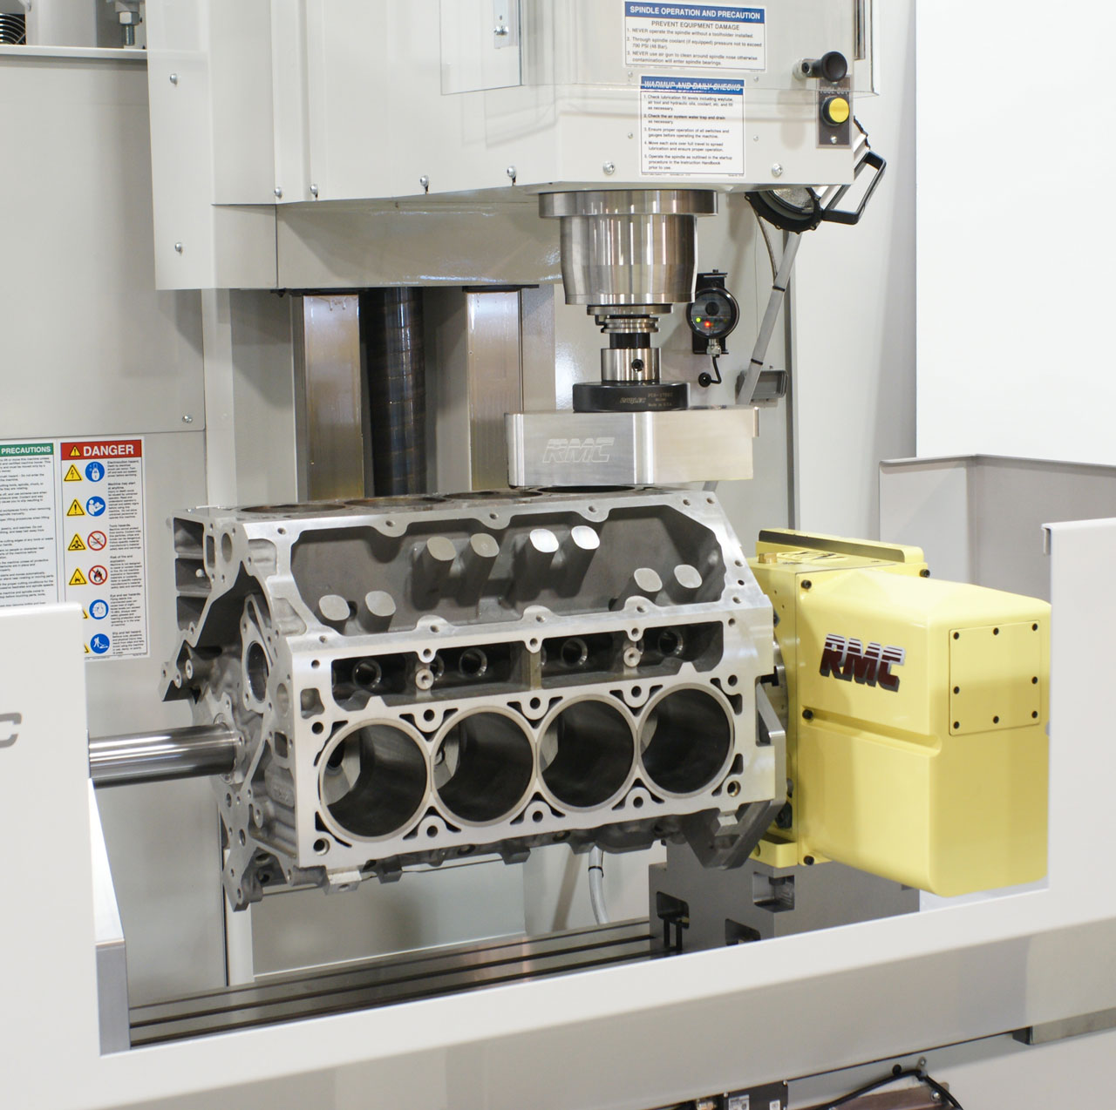

**Figure 2. CNC machine used to refine dimensions on a casted engine block.**

Engine blocks are an example of CNC machining being used as a secondary process in order to further refine or correct dimensions and to smoothen surfaces to increase the surface finish quality. Most engine blocks are manufactured through the sand casting process, where molten metal - usually cast iron for general vehicles or aluminum for high-performance cases - is poured into a sand mold or the desired geometry and allowed to cool. The finished cast is then machined to fine-tune the dimensions and to smooth the surfaces to maximize the performance of the engine block by reducing the friction between the internal components. While CNC machining is still used and is an important part of the manufacturing process, it is a secondary process that mainly serves to refine the preexisting dimensions of the initial cast.

* 1. For the two machining processes and the product examples that you found in Question (1.1), consider which metals and machinings method were possibly involved (substantiate your findings), and then draw up three design guidelines for this combination. Please refer to Philpott’s textbook for hints on acceptable design guidelines; also, at the end of each of the lecture notes you will find an assortment of “design guidelines” for your consideration.) How do you see these rules or guidelines reflected in your product? (15)

The integral machining example included the manufacturing of an aerospace turbine and turbine blades. Aerospace-grade turbines are subjected to the harshest environments among the engine components and must be designed to withstand extremely high temperatures, stresses, and pressures. Hence, the materials used to manufacture these components are generally superalloys, which include alloys of titanium, nickel, cobalt, or composite materials such as ceramics. Alloys that are currently being used in the manufacturing of turbines include titanium aluminide (TiAl), aluminum-lithium (Al-Li) alloys, and Titanium 5553 (Ti-5553) (Standridge). Modern turbine blades also include relatively brittle carbon-fibre blades with titanium edges attached to them. The CNC machining process for aerospace components, including turbines and turbine blades are usually accomplished via 5-axis machining, and can even be extended to 7-axis machining or higher for higher grade components, depending on the complexity of the geometry (Costello). Due to the complex geometry of the turbine, the most likely and common machining process is milling, in which rotary cutting tools are brought into contact with the cutting surface, allowing a variety of geometries to be created by milling.

As stated above, an engine block is an example of CNC machining being used as a secondary process. The two most commonly used metals for engine blocks are cast iron for most commercial cars, and aluminum alloys for higher-end, performance engines (Nguyen). The post-casting machining generally includes boring and milling processes to create additional passages, refine dimensions and improve surface finishing (Pugazhendi).

Several design guidelines can be applied to the combination of milling and boring machining processes used for the two components shown above with regards to the materials used. Firstly, deep and narrow holes should be avoided in both machining operations as they are more difficult to machine and would require a longer and narrower tool, which are more vulnerable to breaking while also resulting in chip removal difficulties. Furthermore, for the boring operation, partial holes where a significant section of the hole is outside of the material should be avoided if possible this can cause the trajectory of the drill to deviate from its original path while drilling through the material. Sharp internal corners should also be avoided by rounding internal corners to a certain radius as the milling process is unable to create sharp internal corners due to the shape of the tool.

The turbine avoids deep and narrow holes as the spacing between the blades are large enough to fit shorter tools with larger diameters whereas the boring holes are sufficiently large enough in diameter. The same is also true for the engine block, which have boring holes with relatively large diameters to compensate for their depth. Both products also avoid any partial holes as the turbine only has a few holes drilled into the solid portion of the component while all the holes on the engine block are situated completely within the material. Additionally, the turbine does not have any sharp internal corners as most of the product is either cylindrical or has curved areas while the joint between the blades and the main turbine body is curved to a certain radius as can be seen in Figure 1 above. This design guideline is satisfied for the engine block as it does not apply to the boring operation and the milling operation is only conducted on the external surface of the engine block to refine dimensions and surface finishing.

* 1. Study par. 8.2.3 in Kalpakjian’s book, “Forces in orthogonal cutting”. Then, with an appropriate diagram/s or sketch/es (like the one shown in Fig. 8.11 (b)), illustrate how the use of a cutting fluid can affect the magnitude of the thrust force, Ft, in orthogonal cutting. Also briefly explain your diagram/s with reference to friction forces, normal force, and rake angle. (15)

The function of a cutting fluid is mainly lubricating the interface between the chip and the cutting edge of the cutting tool. This would reduce the frictional force between the cutting tool and the chip. This reduction in the frictional force reduces the resultant force between the normal and frictional force; the reduction also decreases the shear angle, which in turn reduces the cutting force (Hathikhanavala). Given that both the resultant and cutting forces have decreased, the thrust force, Ft, decreases as well.

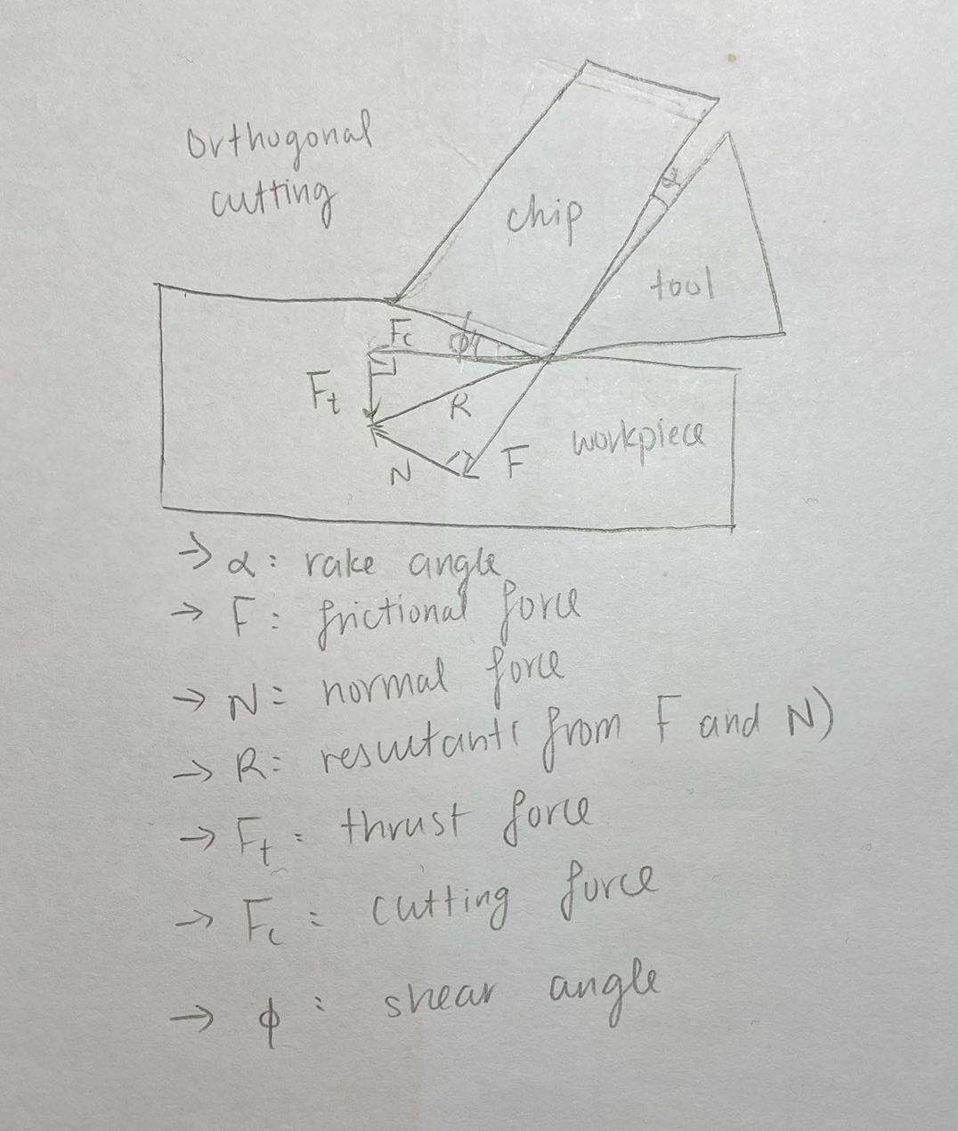

**Figure 3. Diagram of forces in orthogonal cutting.**

When a cutting tool exerts force on a workpiece, it would create a normal force and a frictional force on the workpiece, which would combine into a resultant force that also defines the cutting force and thrust force exerted on the workpiece by the cutting tool. Cutting force is also dependent on the shear angle, which is also dependent on the frictional force. The rake angle is the angle between the chip and the cutting tool that is created. When the frictional force between this interface is high, the forces exerted on the workpiece is high, and vice versa (Hathikhanavala).

* 1. A hole in a steel casting (Sut = 475 MPa) must be bored using a carbide insert. The hole is 130 mm in the as-cast condition; the finished diameter is 138 mm. Suggest (a) a cutting speed and (b) feed, and (c) calculate the required power and (d) cutting force. (20) Hint: For Questions 1.4 (a) and (b), search the Internet for typical values of speed and feed for boring. These should be tabulated like in Table 8.9 of Kalpakjian for turning operations.

1. A metal that matches the ultimate tensile strength in the problem is ASTM A36 Mild/Low Carbon Steel, which has an ultimate tensile strength ranging from 400 - 550 MPa. A suggested cutting speed of this steel is 120 ft/min (AZoM).
2. Since the steel is bored using a carbide insert, the feed rate is 410 ft/min (Little Machine Shop).
3. Values taken from: AZoM, Little Machine Shop, Manufacture Processes for Engineering Materials

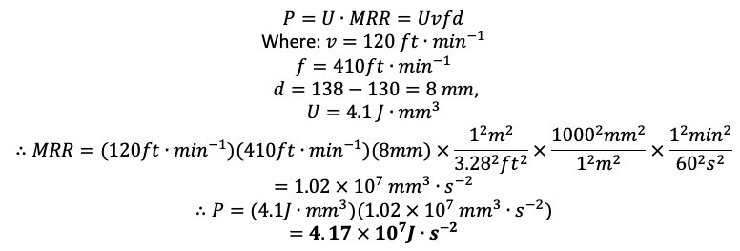

1. Values taken from: Manufacturing Processes for Engineering Materials

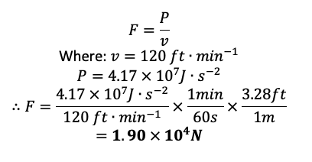

1. **DESIGN CHALLENGE**
   1. Produce a comprehensive table of the process capabilities of the machining processes described in chapter 8 of Kalpakjian’s textbook. Use several columns to describe the machines involved, the typical type of machine tools and cutting-tool materials used, the typical shapes of blanks and parts produced, the typical maximum and minimum sizes produced, the surface finish produced, the dimensional tolerances produced, and the production rates achieved. (30)

**Table 1. Various machining processes and corresponding processing capabilities.**

|  |  |  |  |  |  |  |  |
| --- | --- | --- | --- | --- | --- | --- | --- |
| Process | Machine tool | Cutting-tool materials | Shapes | Typical sizes | Surface finish  (Ra) | Dimensional tolerances (±mm) | Production rates |
| Turning | Lathe | High-speed steel (HSS)  Carbon steel  Carbides  Cobalt HSS | Thin-walled:  Cylindrical  Solid: Cylindrical | Diameter:  0.50-2000 mm | 0.025-25 μm  (Typically 0.4-6.3 μm) | Fine: 0.025-0.13  Rough: 0.13  Skiving: 0.025-0.05 | Manual:  1-60/hour  Automated:  10-1000/hour |
| Boring | Lathe | HSS  Carbides  Tungsten  -carbide | Circular holes (straight or tapered) | 1-1800 mm | 0.025-25 μm  (Typically 0.4-6.3 μm) | 0.025 | Manual:  1-60/hour  Automated:  10-1000/hour |
| Drilling | Lathe, drill press, mill | HSS  Carbides  Carbon steel  Cobalt HSS | Circular holes | Diameter:  0.1-250 mm | 0.8-12.5 μm  (Typically 1.6-6.3 μm) | 0.075 | 1-500/hour |
| Milling | Milling machine | Carbon steel  HSS  Cemented carbides  Cutting ceramic | Cubic and complex solids. | 1-20 mm | 0.2-25 μm  (Typically 0.8-6.3 μm) | 0.13-0.25 | 1-100/hour  (depending on complexity of design) |
| Planing | Planer | HSS  Carbide-tipped | Flat surfaces  Straight slots  Grooves  Pockets | 450-1250 mm | 0.4-25 μm  (Typically 1.6-12.5 μm) | 0.08-0.13 | 1-50/hour |
| Shaping | Shaper | HSS  Carbide-tipped | Flat surfaces  Straight slots  Grooves  Pockets | Small:  < 400mm  Medium:  400-600 mm  Large:  400-1000 mm | 0.4-25 μm  (Typically 1.6-12.5 μm) | 0.05-0.13 | 1-50/hour |
| Broaching | Broach | HSS,  Carbide inserts | Assorted, depending on the geometry of the broach and workpiece. | Internal:  3.2-152.4 mm  Surface broaches:  1.9-254 mm | 0.4-6.3 μm  (Typically 0.8-3.2 μm) | 0.025-0.15 | Up to 400/hour |
| Sawing | Saw blade | Carbon steel  HSS  Solid-carbide  Carbide-tipped  Diamond tipped | Assorted, linear or curved. | Power hacksaws:  1.2-2.5 mm thick  Power band saws:  0.08-13 mm | 0.8-50 μm  (Typically 1.6-25 μm) | 0.8 | Tens to hundreds per hour  (depending on complexity of design) |

* 1. The accompanying illustration shows drawings for a cast-steel valve body before (left) and after (right) machining. Identify the surfaces that must be machined. What type of machine tool would be suitable to machine this part? What type of machining operations are involved, and what should be the sequence of these operations? (Note that not all surfaces are to be machined.) (10)

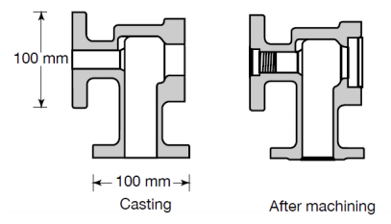

**Figure 4. Cross-section of cast-steel valve body before (left) and after (right) machining**

From Figure 4 above, the bottom feature is machined via turning on a lathe. A chamfer was machined on the inner circumference by using a chamfer tool. For the features on the upper left of the part, the surface finishing of the existing hole would be refined through boring on a lathe. Due to the sharp inner radius as illustrated above, the larger diameter hole closer to the surface would also be created through boring on a lathe, while the inner threads are generated via tapping, also done on a lathe. Following that, the outer edge of the hole would then be chamfered by turning on a lathe with a chamfer tool. For the features on the upper right, the diameter of the existing hole would be firstly enlarged by boring on a lathe, due to the sharp inner corner of the hole. Subsequent rounding of the external corners of the hole would be done via turning on a lathe.

Works Cited

1. “ASTM A36 Mild/Low Carbon Steel.” *AZoM.com*, AZO Materials, 5 July 2012, www.azom.com/article.aspx?ArticleID=6117.
2. “Broaching.” *Mechanciatech.com*, Mechanica Technical Solutions, www.mechanicatech.com/Machining/broaching.html.
3. Costello, Mike. “Turbine Blade Milling for Medium-to-Large Jet Engines.” *Aerospace Manufacturing and Design*, Aerospace Manufacturing and Design, 15 Aug. 2019, www.aerospacemanufacturinganddesign.com/article/turbine-blade-milling-for-medium-to-large-jet-engines/.
4. “Cutting Speeds.” *LittleMachineShop.com*, LittleMachineShop.com, littlemachineshop.com/reference/cuttingspeeds.php.
5. “Drilling.” *Mechanciatech.com*, Mechanica Technical Solutions, www.mechanicatech.com/Machining/drilling.html.
6. Geshelin, Joseph. “Current Practise in Surface Broaching.” Trans. Of ASME, 56, Philadelphia, PA.
7. Hathikhanavala, Bomi Ardeshir, "The effect of lubri-coolant application at the tool-chip interface on tool forces" (1965). Masters Theses. 5335. https://scholarsmine.mst.edu/masters_theses/5335.
8. “Milling.” *Mechanciatech.com*, Mechanica Technical Solutions, www.mechanicatech.com/Machining/milling.html.
9. Nguyen, Hieu. “Manufacturing Processes and Engineering Materials Used in Automotive Engine Blocks.” Grand Valley State University School of Engineering, 2005.
10. Pintu. “Difference Between Shaping and Planing.” *Difference.minaprem.com*, Minaprem, 6 June 2019, www.difference.minaprem.com/machining/difference-between-shaping-and-planing/.
11. Pugazhendi, S. “*Engine Block Manufacturing”*, CDX Automotive, prod.lv2014.gener8cms.net/index.php/40-disc-brakes/section-2/enblco/2731-engine-block-manufacturing.
12. Standridge, Michael. “Aerospace Materials - Past, Present, and Future.” Aerospace Manufacturing and Design, Aerospace Manufacturing and Design, 13 Aug. 2014, www.aerospacemanufacturinganddesign.com/article/amd0814-materials-aerospace-manufacturing/.
13. Tate, Christopher. *Choosing the Right Boring Tool*, Cutting Tool Engineering, 29 Oct. 2019, www.ctemag.com/news/articles/choosing-right-boring-tool.
14. “Turning.” *CustomPart.Net*, CustomPartNet, www.custompartnet.com/wu/turning.
15. “Turning and Boring.” *Mechanciatech.com*, Mechanica Technical Solutions, www.mechanicatech.com/Machining/turningandboring.html.